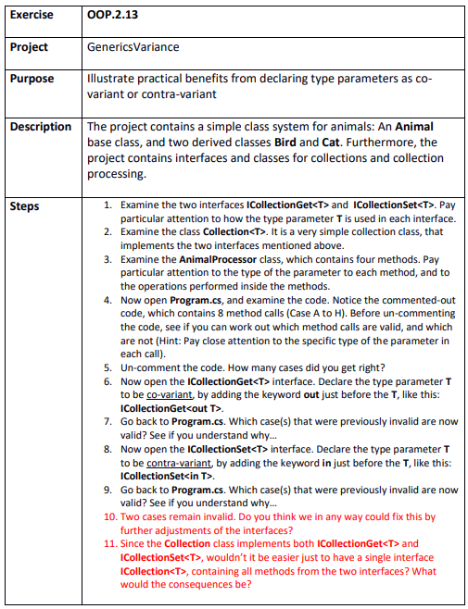

Step 1& 2
C:\Git\OOProg25\Chap\OOProg02\MySolution\OOP.2.13 - GenericsVariance\GenericsVariance\GenericsVariance.sln

Step 3
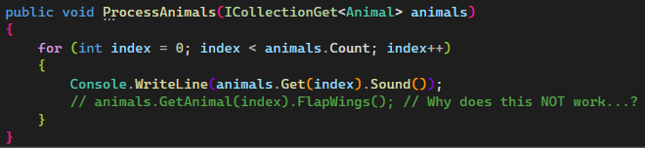
Doesn’t work because GetAnimal is not a declared method within ICollectionGet<T>
It should be Get
Also doesn’t work because FlapWings is a method of the Bird class and the type is Animal, so the collection might as well contain cats wich cannot flap their wings
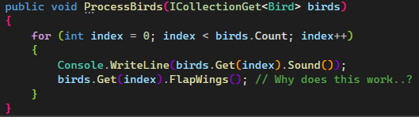
Here the type is strictly set to Bird and the method call is correct using Get and not GetAnimal.
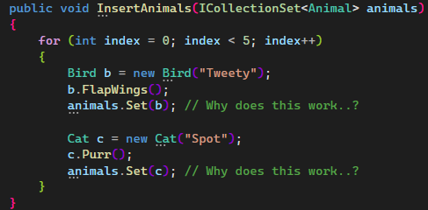
Because the collection takes Animal objects and both cats and birds are objects of type Animal
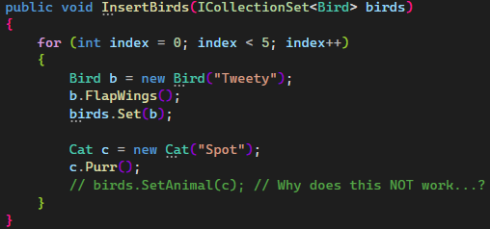
Because this collection is declared as Bird which only receives birds

Step 4
Prediction: Case D and H will fail
Reality: Case A, D, E and H failed

Step 5
6 out of 8 right

Step 10
Idk

Step 11
The entire interface would be invariant and will be more type strict.

